1. 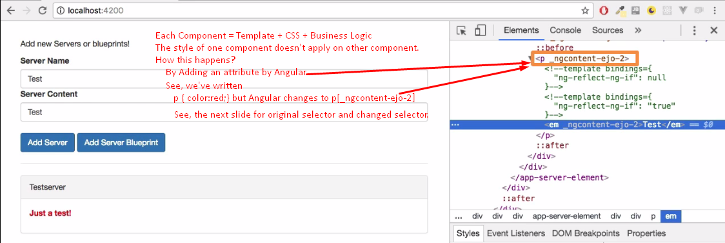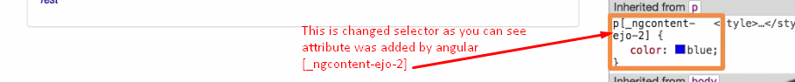
2. All these strange attributes applied to all tags in template.
3. Each component has its one unique attribute all over its tags.
4. Actually, there is a technology called **shadow dom** when you want to apply a style to a particular sub-DOM but angular uses its own way like adding its own attribute to css.